University of Phoenix Material

Programming Assignment Worksheet

To: Troy Tucket
From: Learning Team C: Timothy Fletcher-Justin Amescua-Elbio Iseas-Leif Rebuck-Michelle Patino
Date: 11/28/2015
Assignment: Theatre seating program

Requirements:
Defined requirements:
- The program should display a screen that shows which seats are available and which are taken.
- Every time a ticket or group of tickets is purchased, the program should display the total ticket prices and update the seating chart.
- The program should keep a total of all ticket sales.
- The program should also give the user an option to see a list of how many seats have been sold, how many seats are available in each row, and how many seats are available in the entire auditorium.

Design:
- Define Globals.
- Program execution from Main Method:
  - Loads information from the storage system text file.
  - Sets the color to Blue.
  - Displays the introduction screen.
    - Waits for any key to proceed.
  - Displays the main menu screen.
    - Accepts and evaluates user input and directs application to appropriate module.
  - Passes user selection to control switch:
      - Selling Tickets
        - Display seating chart
        - User input: Choose a Row
        - User input Choose a Seat
          - Process seat selection
            - If 0, exit to main menu
            - If valid seat selection:
              - Alert seat sold, reset window
              - Display price of seat, confirm purchase
                - If yes update sale in charts, and sales. Reset window.
                - If no, reset window.
      - Total of all ticket sales
        - Calculate and display seat sales for each row.
        - Calculate and display total seat sales.
        - User Input: Any key returns to Main Menu.
      - List of sold tickets
        - Display chart showing seats sold.
        - User Input: Any key returns to Main Menu.
      - Available Seats per Row
        - Display chart showing available seats in each row.
        - User Input: Any key returns to Main Menu.
      - Available Seats in Auditorium
        - Display chart showing quantity of seats available in each row.
        - User Input: Any key returns to Main Menu.
- Exit the Program
- End of Main Method and program

- Global definitions:
- Define char array for each row, initialized to “#” (row1-row0)
- Define int array for seats per row (auditoriumSeats)
- Define double array for seat prices for each row (seatPricesByRow)
- Define double array to store sales for each row (soldPerRow)
- Define Boolean variable representing seat availability (soldOut)
- Define Function, no return, loop delay in mSecs (sleep)
- Define Function, no return, cursor positioning (gotoxy)
- Define Function, no return, message display (say)
- Define Function, no return, clears the screen (clearscreen)
- Define Function, no return, applies pattern for borders (drawboxborder)
- Define Function, no return, draws a box based on symbol passed as argument (paintbox)
- Define Function, no return, reads seat data from file (readFromFile
- Define Function, no return, saves seat data to a text file (saveToFile)
- Define Function, returns char, operation confirmation (confirm)
- Define Function, no return, updates seat from # to * when selected (updateLocation)
- Define Function, no return, displays seat availability per row (displaySeats)
- Define Function, no return, update seat status (refreshChart)
- Define Function, returns bool, updates status of soldOut when sold out(soldOutSeats)
- Define Function, returns bool, checks seat availability (available)
- Define Function, returns int, main menu control loop, sentinel initialized to 54 (chooseTask)
- Define Function, returns int, accepts user input for seat selection. (readSeatToSell)
- Define Function, returns int, user input for range of row(readRow)
- Define Function, no return, allows user to select a seat for purchase (tickets)
- Define Function, no return, calculates total ticket sales(totalTicketSales)
- Define Function, no return, display sales for each row and total (totalTickets)
- Define Function, no return, display available seats per row (seatsAvailabilityperRow)
- Define Function, returns int, calculates available seats per row(availableSeatsPerRow)
- Define Function, no return, display available seats in auditorium (seatsAvailinAuditorium)
- Define Function, no return, display the main menu (displayMenu)
- Define Function, no return, display the program introduction (intro)
- Define Function, no return, delay loop (sleep)
- Define Function, no return, draws the seat availability chart (drawChart)
Source Programs:
// =====================================================================================
// TheaterSeatingProgram.cpp : Defines the entry point for the console application.
// Author : Learning Team C - University of Phoenix 2015 -
// Timothy Fletcher, Justin Amescua, Elbio Iseas, Leif Rebuck, Michelle Patino
// =====================================================================================
#include "stdafx.h"
#include <iostream>
#include <iomanip>
#include <conio.h>
#include <array>
#include <cstdlib>
#include <stdlib.h>
#include <ctime>
#include <string>
#include <windows.h>
#include <fstream>

#define ESC 27

using namespace std;

// =====================================================
// theater seat availability by row from row 1 to 10
// =====================================================
char row1[] = { '#', '#', '#', '#', '#', '#', '#', '#', '#', '#' };
char row2[] = { '#', '#', '#', '#', '#', '#', '#', '#', '#', '#' };
char row3[] = { '#', '#', '#', '#', '#', '#', '#', '#', '#', '#' };
char row4[] = { '#', '#', '#', '#', '#', '#', '#', '#', '#', '#' };
char row5[] = { '#', '#', '#', '#', '#', '#', '#', '#', '#', '#' };
char row6[] = { '#', '#', '#', '#', '#', '#', '#', '#', '#', '#' };
char row7[] = { '#', '#', '#', '#', '#', '#', '#', '#', '#', '#' };
char row8[] = { '#', '#', '#', '#', '#', '#', '#', '#', '#', '#' };
char row9[] = { '#', '#', '#', '#', '#', '#', '#', '#', '#', '#' };
char row0[] = { '#', '#', '#', '#', '#', '#', '#', '#', '#', '#' };
// ===============================================
// theater seat availability in the Auditorium
// ===============================================
int auditoriumSeats[] = { 10, 10, 10, 10, 10, 10, 10, 10, 10, 10 };
// =====================================================================================
// Seat prices by row # : 1 2 3 4 5 6 7 8 9 10
// =====================================================================================
double seatPricesByRow[] = { 60.00, 55.00, 50.00, 45.00, 40.00, 35.00, 30.00, 25.00, 20.00, 15.00 };
// =========================================================
// array to keep the dolar amount of tickets sold by row
// =========================================================
double soldPerRow[] = { 0.00, 0.00, 0.00, 0.00, 0.00, 0.00, 0.00, 0.00, 0.00, 0.00 };
// ============================================================
// boolean soldOut sentinel for when all seats are sold out
// ============================================================
bool soldOut = false;
// =============================================================
// function to delaying a loop in miliseconds as an argument
// =============================================================
void sleep(unsigned int);
// ============================================================================================================
// https://msdn.microsoft.com/en-us/library/windows/desktop/ms686025(v=vs.85).aspx
// result of the online research for the old C language function for positioning the cursor
// The purpose of this function is to position the cursor on screen
// so there is no need to use endl or leading blanks
// ============================================================================================================
void gotoxy(int x, int y) // function with the two int parameters x, and y for column, and row respectively
{
HANDLE hStdOut = GetStdHandle(STD_OUTPUT_HANDLE);
COORD coord; // it creates an object COORD named coord for the screen coordinates
coord.X = x; // it assigns the value of the parameter x (column) to the object coord.X
coord.Y = y; // it assigns the value of the parameter y (row) to the object coord.Y
SetConsoleCursorPosition(hStdOut, coord); // it sets the cursor position with the values of the object coord
}
// ========================================================================================
// this function displays a message or character in the x, y coordinates of the console
// x is the column argument to display the message
// y is the line argument to display the message
// message is the argument you want to display at the coordinates x, y
// ========================================================================================
void say(int x, int y, string message)
{
gotoxy(x, y);
cout << message;
}
// =========================================================
// this function when called it clear the console screen
// it uses the system OS command CLS
// =========================================================
void clearscreen()
{
system("CLS");
}
// ==================================================================
// this function makes the border of a box with five parameters :
// top left screen column coordinate
// top left screen line coordinate
// bottom right screen column coordinate
// bottom right screen line coordinate
// the parameter symbol can have one of three possible values
// 0 for blank
// 1 for single line
// 2 for double line
// ===========================================================================
void drawboxborder(int x1, int y1, int x2, int y2, int symbol)
{
string topleftcorner,
toprightcorner,
bottomleftcorner,
bottomrightcorner,
topsymbol,
bottomsymbol,
leftsymbol,
rightsymbol;

if (symbol == 0)
{
topleftcorner = " ";
toprightcorner = " ";
bottomleftcorner = " ";
bottomrightcorner = " ";
topsymbol = " ";
bottomsymbol = " ";
leftsymbol = " ";
rightsymbol = " ";
}
else if (symbol == 1 || symbol == 2)
{
topleftcorner = (symbol == 1) ? "Ú" : "É";
toprightcorner = (symbol == 1) ? "¿" : "»";
bottomleftcorner = (symbol == 1) ? "À" : "È";
bottomrightcorner = (symbol == 1) ? "Ù" : "¼";
topsymbol = (symbol == 1) ? "Ä" : "Í";
bottomsymbol = (symbol == 1) ? "Ä" : "Í";
leftsymbol = (symbol == 1) ? "³" : "º";
rightsymbol = (symbol == 1) ? "³" : "º";
}

if (symbol >= 0 && symbol <= 2)
{
int col, line;

say(x1, y1, topleftcorner);
say(x2, y1, toprightcorner);

for (col = x1 + 1; col <= x2 - 1; col++)
say(col, y1, topsymbol);
for (line = y1 + 1; line <= y2 - 1; line++)
{
say(x1, line, leftsymbol);
say(x2, line, rightsymbol);
}

say(x1, y2, bottomleftcorner);
say(x2, y2, bottomrightcorner);

for (col = x1 + 1; col <= x2 - 1; col++)
say(col, y2, bottomsymbol);
}
}
// ===========================================================================
// this function paints a screen box with the symbol passed as an argument
// x1 is the left column value of the top left corner
// y1 is the top line value for the top left corner
// x2 is the right column value of the bottom right corner
// y2 is the bottom line value of the bottom right corner
// symbol is the character you pass as argument to fill the box
// ===========================================================================
void paintbox(int x1, int y1, int x2, int y2, string symbol)
{
int col, line;
for (line = y1; line <= y2; line++)
{
for (col = x1; col <= x2; col++)
say(col, line, symbol);
}

}
// ==========================================================
// module for reading file with available and taken seats
// ==========================================================
void readFromFile()
{
ifstream textFile; // it creates a input file named textFile

textFile.open("theaterseats.txt"); // it opens the file with the physical name "theaterseats.txt"

if (textFile.fail()) // if it fails to open the file executes the block
{

ofstream textFile; // it creates an output file named textFile

textFile.open("theaterseats.txt"); // it opens the file with the physical name "theaterseats.txt"

textFile << row1; // saves the array row1 to disk
textFile << row2; // saves the array row2 to disk
textFile << row3; // saves the array row3 to disk
textFile << row4; // saves the array row4 to disk
textFile << row5; // saves the array row5 to disk
textFile << row6; // saves the array row6 to disk
textFile << row7; // saves the array row7 to disk
textFile << row8; // saves the array row8 to disk
textFile << row9; // saves the array row9 to disk
textFile << row0; // saves the array row0 to disk

textFile.close(); // it closes the file
}
else // if the files exists it executes the next block
{

char line[100]; // it creates a char array of 100 elements, named line
char aChar = ' '; // it creates a char variable named aChar

ifstream textFile; // it creates an input file name textFile

textFile.open("theaterseats.txt"); // it opens a file named "theaterseats.txt"

for (int i = 0; i < 100; i++) // if runs a for loop of 100 cycles
{
textFile.get(aChar); // it gets a char from the file into the variable aChar
line[i] = aChar; // it assigns that char to the char array line
}
for (int i = 0; i < 10; i++) // it runs a for loop of 10 cycles
{
row1[i] = line[i]; // it loads a specific char from the line array into the row arrays
row2[i] = line[i + 10]; // it loads a specific char from the line array into the row arrays
row3[i] = line[i + 20]; // it loads a specific char from the line array into the row arrays
row4[i] = line[i + 30]; // it loads a specific char from the line array into the row arrays
row5[i] = line[i + 40]; // it loads a specific char from the line array into the row arrays
row6[i] = line[i + 50]; // it loads a specific char from the line array into the row arrays
row7[i] = line[i + 60]; // it loads a specific char from the line array into the row arrays
row8[i] = line[i + 70]; // it loads a specific char from the line array into the row arrays
row9[i] = line[i + 80]; // it loads a specific char from the line array into the row arrays
row0[i] = line[i + 90]; // it loads a specific char from the line array into the row arrays
}

textFile.close(); // it closes the file textFile
}

textFile.close(); // it closes the file textFile

}
// ================================
// module to save seats to file
// ================================
void saveToFile()
{
ofstream textFile; // it creates an output file named textFile

textFile.open("theaterseats.txt"); // it opens the file with the physical name "theaterseats.txt"

textFile << row1; // saves the array row1 to disk
textFile << row2; // saves the array row2 to disk
textFile << row3; // saves the array row3 to disk
textFile << row4; // saves the array row4 to disk
textFile << row5; // saves the array row5 to disk
textFile << row6; // saves the array row6 to disk
textFile << row7; // saves the array row7 to disk
textFile << row8; // saves the array row8 to disk
textFile << row9; // saves the array row9 to disk
textFile << row0; // saves the array row0 to disk

textFile.close(); // it closes the file textFile

ofstream backupFile; // it creates an output file named backupFile

backupFile.open("backuptheaterseats.txt"); // it opens this file for writing and it gives the name "backuptheaterseats.txt"

backupFile << row1; // saves the array row1 to disk
backupFile << row2; // saves the array row2 to disk
backupFile << row3; // saves the array row3 to disk
backupFile << row4; // saves the array row4 to disk
backupFile << row5; // saves the array row5 to disk
backupFile << row6; // saves the array row6 to disk
backupFile << row7; // saves the array row7 to disk
backupFile << row8; // saves the array row8 to disk
backupFile << row9; // saves the array row9 to disk
backupFile << row0; // saves the array row0 to disk

backupFile.close(); // it closes the file backupFile
}
// ======================================
// module for confirming an operation
// it returns a char Y/y/N/n
// ======================================
char confirm()
{
char resp = ' '; // it creates a char variable and initializes with blank

while (resp != 'Y'&& resp != 'y'&& resp != 'N'&& resp != 'n') // it will keep in the while loop until resp is Y/y/N/n
{
say(42, 22, " "); // it displays a blank at 10,18
gotoxy(42, 22); // it moves the cursor to the coordinates specified
resp = getch(); // it gets a character from them keyboard
cout << resp; // display that character on screen
}

return resp;
}
// ==========================================================
// module for updating the state of the seat to '*' Taken
// ==========================================================
void updateLocation(int rowNum, int seatNum)
{
switch (rowNum) // starts evaluating rowNum
{
case 1: // when row is 1
row1[seatNum - 1] = '*'; // it updates the availability of the seat
break; // it exits the switch statement
case 2: // when row is 2
row2[seatNum - 1] = '*'; // it updates the availability of the seat
break; // it exits the switch statement
case 3: // when row is 3
row3[seatNum - 1] = '*'; // it updates the availability of the seat
break; // it exits the switch statement
case 4: // when row is 4
row4[seatNum - 1] = '*'; // it updates the availability of the seat
break; // it exits the switch statement
case 5: // when row is 5
row5[seatNum - 1] = '*'; // it updates the availability of the seat
break; // it exits the switch statement
case 6: // when row is 6
row6[seatNum - 1] = '*'; // it updates the availability of the seat
break; // it exits the switch statement
case 7: // when row is 7
row7[seatNum - 1] = '*'; // it updates the availability of the seat
break; // it exits the switch statement
case 8: // when row is 8
row8[seatNum - 1] = '*'; // it updates the availability of the seat
break; // it exits the switch statement
case 9: // when row is 9
row9[seatNum - 1] = '*'; // it updates the availability of the seat
break; // it exits the switch statement
case 10: // when row is 10
row0[seatNum - 1] = '*'; // it updates the availability of the seat
break; // it exits the switch statement
default: // exception condition
{
say(4, 21, "Exception condition found."); // it displays the exception condition message
say(4, 22, "Press any key to continue ... "); // it displays the message to continue
getch(); // it waits for the user to press any key
}
}
}
// =========================================================================================
// this module displays the seats availability of a specific row received as an argument
// =========================================================================================
void displaySeats(int rownum)
{
int row;
switch (rownum)
{
case 1:
row = 3;
gotoxy(58, row);
cout << row1[0];
gotoxy(60, row);
cout << row1[1];
gotoxy(62, row);
cout << row1[2];
gotoxy(64, row);
cout << row1[3];
gotoxy(66, row);
cout << row1[4];
gotoxy(68, row);
cout << row1[5];
gotoxy(70, row);
cout << row1[6];
gotoxy(72, row);
cout << row1[7];
gotoxy(74, row);
cout << row1[8];
gotoxy(76, row);
cout << row1[9];
break;
case 2:
row = 5;
gotoxy(58, row);
cout << row2[0];
gotoxy(60, row);
cout << row2[1];
gotoxy(62, row);
cout << row2[2];
gotoxy(64, row);
cout << row2[3];
gotoxy(66, row);
cout << row2[4];
gotoxy(68, row);
cout << row2[5];
gotoxy(70, row);
cout << row2[6];
gotoxy(72, row);
cout << row2[7];
gotoxy(74, row);
cout << row2[8];
gotoxy(76, row);
cout << row2[9];
break;
case 3:
row = 7;
gotoxy(58, row);
cout << row3[0];
gotoxy(60, row);
cout << row3[1];
gotoxy(62, row);
cout << row3[2];
gotoxy(64, row);
cout << row3[3];
gotoxy(66, row);
cout << row3[4];
gotoxy(68, row);
cout << row3[5];
gotoxy(70, row);
cout << row3[6];
gotoxy(72, row);
cout << row3[7];
gotoxy(74, row);
cout << row3[8];
gotoxy(76, row);
cout << row3[9];
break;
case 4:
row = 9;
gotoxy(58, row);
cout << row4[0];
gotoxy(60, row);
cout << row4[1];
gotoxy(62, row);
cout << row4[2];
gotoxy(64, row);
cout << row4[3];
gotoxy(66, row);
cout << row4[4];
gotoxy(68, row);
cout << row4[5];
gotoxy(70, row);
cout << row4[6];
gotoxy(72, row);
cout << row4[7];
gotoxy(74, row);
cout << row4[8];
gotoxy(76, row);
cout << row4[9];
break;
case 5:
row = 11;
gotoxy(58, row);
cout << row5[0];
gotoxy(60, row);
cout << row5[1];
gotoxy(62, row);
cout << row5[2];
gotoxy(64, row);
cout << row5[3];
gotoxy(66, row);
cout << row5[4];
gotoxy(68, row);
cout << row5[5];
gotoxy(70, row);
cout << row5[6];
gotoxy(72, row);
cout << row5[7];
gotoxy(74, row);
cout << row5[8];
gotoxy(76, row);
cout << row5[9];
break;
case 6:
row = 13;
gotoxy(58, row);
cout << row6[0];
gotoxy(60, row);
cout << row6[1];
gotoxy(62, row);
cout << row6[2];
gotoxy(64, row);
cout << row6[3];
gotoxy(66, row);
cout << row6[4];
gotoxy(68, row);
cout << row6[5];
gotoxy(70, row);
cout << row6[6];
gotoxy(72, row);
cout << row6[7];
gotoxy(74, row);
cout << row6[8];
gotoxy(76, row);
cout << row6[9];
break;
case 7:
row = 15;
gotoxy(58, row);
cout << row7[0];
gotoxy(60, row);
cout << row7[1];
gotoxy(62, row);
cout << row7[2];
gotoxy(64, row);
cout << row7[3];
gotoxy(66, row);
cout << row7[4];
gotoxy(68, row);
cout << row7[5];
gotoxy(70, row);
cout << row7[6];
gotoxy(72, row);
cout << row7[7];
gotoxy(74, row);
cout << row7[8];
gotoxy(76, row);
cout << row7[9];
break;
case 8:
row = 17;
gotoxy(58, row);
cout << row8[0];
gotoxy(60, row);
cout << row8[1];
gotoxy(62, row);
cout << row8[2];
gotoxy(64, row);
cout << row8[3];
gotoxy(66, row);
cout << row8[4];
gotoxy(68, row);
cout << row8[5];
gotoxy(70, row);
cout << row8[6];
gotoxy(72, row);
cout << row8[7];
gotoxy(74, row);
cout << row8[8];
gotoxy(76, row);
cout << row8[9];
break;
case 9:
row = 19;
gotoxy(58, row);
cout << row9[0];
gotoxy(60, row);
cout << row9[1];
gotoxy(62, row);
cout << row9[2];
gotoxy(64, row);
cout << row9[3];
gotoxy(66, row);
cout << row9[4];
gotoxy(68, row);
cout << row9[5];
gotoxy(70, row);
cout << row9[6];
gotoxy(72, row);
cout << row9[7];
gotoxy(74, row);
cout << row9[8];
gotoxy(76, row);
cout << row9[9];
break;
case 10:
row = 21;
gotoxy(58, row);
cout << row0[0];
gotoxy(60, row);
cout << row0[1];
gotoxy(62, row);
cout << row0[2];
gotoxy(64, row);
cout << row0[3];
gotoxy(66, row);
cout << row0[4];
gotoxy(68, row);
cout << row0[5];
gotoxy(70, row);
cout << row0[6];
gotoxy(72, row);
cout << row0[7];
gotoxy(74, row);
cout << row0[8];
gotoxy(76, row);
cout << row0[9];
break;
default:
{
say(3, 21, "Invalid row number. Press any key ... ");
getch();
}
}

}
// =============================================
// module for updating the state of the seat
// =============================================
void refreshChart(int rowNumber)
{
displaySeats(rowNumber);
}
// =============================================
// module for updating the state of the seat
// =============================================
bool soldOutSeats()
{
bool noMoreSeats = true; // sets the bool variable to true

for (int i = 0; i < 10; i++) // initiates the for loop to check for available seats in the theater
{
// evaluates the ten rows for available seats
if (row1[i] == '#' || row2[i] == '#' || row3[i] == '#' || row4[i] == '#' || row5[i] || row6[i] == '#' || row7[i] == '#' || row8[i] == '#' || row9[i] == '#' || row0[i] == '#')
{
noMoreSeats = false; // sets the bool variable to false
break; // it exits the for loop because there is at least one seat available
}
}

return noMoreSeats; // it returns a false or true value depending on if the theater seats are sold out or not
}
// =========================================
// module for checking seat availability
// =========================================
bool available(int row, int seatnum)
{
bool retvalue = false;
int seat = 1;
seat = seatnum - 1;

switch (row)
{
case 1:
retvalue = (row1[seat] == '#') ? true : false;
break;
case 2:
retvalue = (row2[seat] == '#') ? true : false;
break;
case 3:
retvalue = (row3[seat] == '#') ? true : false;
break;
case 4:
retvalue = (row4[seat] == '#') ? true : false;
break;
case 5:
retvalue = (row5[seat] == '#') ? true : false;
break;
case 6:
retvalue = (row6[seat] == '#') ? true : false;
break;
case 7:
retvalue = (row7[seat] == '#') ? true : false;
break;
case 8:
retvalue = (row8[seat] == '#') ? true : false;
break;
case 9:
retvalue = (row9[seat] == '#') ? true : false;
break;
case 10:
retvalue = (row0[seat] == '#') ? true : false;
break;
}

return retvalue;
}
// =============================
// int chooseTask() module
// =============================
int chooseTask()
{
char aKey = 54; // it assigns a value out of range to the var aKey to push it in the while loop

// it will stay in the loop as long as the key pressed is different from 0-5 or ESC

while (aKey != 48 && aKey != ESC && aKey != 49 && aKey != 50 && aKey != 51 && aKey != 52 && aKey != 53)
{
gotoxy(39, 22); // it moves the cursor to the reading position
aKey = getch(); // it waits for a key to be pressed and it assigns it to the variable aKey
}
if (aKey == ESC) // if the key pressed was ESC then it enters the block
{
aKey = 48; // it assigns the integer value of '0' to the variable aKey
}
return aKey; // it returns the select key of the main menu
}
// ================================================
// this functions accepts the user's input in a
// specific range for selecting a seat number
// ================================================
int readSeatToSell()
{
int seatNumber = -1; // initializes the var seatNumber in -1

paintbox(3, 21, 46, 22, " "); // it clears any message in the message area
say(8, 22, "Enter a seat number from 1 to 10"); // it displays the message to enter the seat number

while (seatNumber < 1 || seatNumber > 10) // it stays in the loop while seatNumber is not in the range 0 - 10
{
say(37, 12, " "); // it clears the old rowNumber if it was out of range
gotoxy(37, 12); // it positions the cursor ready for input
cin >> seatNumber; // it prompts the user to enter the rowNumber
}

return seatNumber; // it returns the seatNumber
}
// ================================================
// this functions accepts the user's input in a
// specific range for selecting a row number
// ================================================
int readRow()
{
int rowNumber = -1; // initializes the var rowNumber in -1

paintbox(3, 21, 46, 22, " "); // it clears any message in the message area
say(6, 22, "Enter a Row number [1-10], or 0 to exit"); // it displays a message asking the user to enter a row number

while (rowNumber < 0 || rowNumber > 10) // it stays in the loop while rowNumber is not in the range 0 - 10
{
say(37, 10, " "); // it clears the old rowNumber if it was out of range.
gotoxy(37, 10); // it positions the cursor ready for input
cin >> rowNumber; // it prompts the user to enter the rowNumber
}

return rowNumber; // it returns the rowNumber
}
// ==========================
// Tickets module
// ==========================
void tickets()
{
int row = 1; // it creates an int variable row and it initializes in 1
int seatToSell = 1; // it creates an int variable setToSell and initializes in 1
bool seatAvailable = false; // it creates a boolean variable seatAvailable and it initializes in false
char answer = ' '; // it creates a char variable answer and initializes in blank
double price = 0.00; // it creates a double variable price and initializes in 0.00
say(3, 1, " "); // it erases last screen title
say(8, 1, "T I C K E T S F O R S A L E"); // it displays the title of the task to do
paintbox(2, 3, 46, 19, " "); // it clears just the place of the menu items
paintbox(3, 21, 46, 22, " "); // it clears the messaging box
drawboxborder(2, 5, 47, 19, 1); // it draws a box border with single line
if (!soldOut) // it the theater seats are not sold out
{
say(12, 10, "Choose a Row [1...10] : "); // it displays a message for choosing a row
say(12, 12, "Choose a Seat [1...10] : "); // it displays a message for choosing a seat
say(6, 22, "Enter a Row number [1-10], or 0 to exit"); // it displays a message asking the user to enter a row number

while (row != 0 && !soldOut) // it will stay in the loop until no more seats available or finish selling seats
{
say(37, 10, " "); // it clears the last row number
say(37, 12, " "); // it clears the last seat number
gotoxy(37, 10); // it moves the cursor to the place where the user enters the row number
seatToSell = 0; // it initializes seatToSell in zero
row = 0; // it initializes the variable row in zero
row = readRow(); // it calls the module to read a row and it assigns it to the variable row
if (row != 0)
{
say(4, 16, " "); // it clears the message saying the price of the seat location in $
say(6, 22, " "); // it clears the message asking the user to enter a row number
say(5, 22, " "); // it clears the message for confirming the sale of the seat
say(4, 22, "Enter a Seat number from 1 to 10"); // it displays a message to enter a seat number
gotoxy(37, 12); // it moves the cursor to the place to read the seat number
seatToSell = 0; // it initializes seatToSell in zero
seatToSell = readSeatToSell(); // it calls the module readSeatToSell and it assigns the seat number to seatToSell
seatAvailable = available(row, seatToSell); // it checks for seat availability and assigns true or false depending on availability
if (seatAvailable) // if the seat is available it enters the block
{
price = seatPricesByRow[row - 1]; // it assigns the price of the seat to the variable price
say(4, 16, "The price for this seat location is $ "); // it displays the message saying the price of the seat location in $
cout << setw(2) << price; // it displays the price of the seat in a three digits format
paintbox(3, 21, 46, 22, " "); // it clears the messaging box
say(5, 22, "Confirm the sale of this seat? (Y/N) "); // it displays a message for confirming the sale of the seat
gotoxy(42, 22); // it moves the cursor to the confirming position on screen
answer = confirm(); // it calls the module confirm() to get an response Y/y/N/n and assigns it to answer
if (answer == 'Y' || answer == 'y') // if the answer was 'Y' or 'y' then it enters the block
{
updateLocation(row, seatToSell); // it updates the location of the seat to taken '*'
refreshChart(row); // it refreshes the row of the seat sold
soldOut = soldOutSeats(); // it calls the module soldOutSeats() and it assigns the result (true/false) to the variable soldOut
}
say(5, 22, " "); // it erases a message for confirming the sale of the seat
say(4, 16, " "); // it erases the message for selling the seat
}
else // if not, display a message saying Seat sold
{
paintbox(3, 21, 46, 22, " "); // it clears the message box
say(4, 22, "Seat sold. Press any key to continue... "); // it displays the inavailability message
getch(); // it waits for the user to press any key to continue
say(4, 22, " "); // it clears the inavailability message
}
say(6, 22, "Enter a Row number [1-10], or 0 to exit"); // it displays a message asking the user to enter a row number
}
if (soldOut) // if the reason for exiting was there were no more seats available
{
paintbox(3, 21, 46, 22, " "); // it clears the messages box
say(4, 21, "All the seats in the theater are sold out."); // it displays the message for sold out seats
say(4, 22, "Press any key to return to Main Menu ... "); // it displays a message to press any key to return to Main Menu
getch(); // it waits for the user to press any key
}
}
}
else // the theater seats are sold out
{
say(4, 21, "All the seats in the theater are sold out."); // it dispalys a message for this reason
say(4, 22, "Press any key to return to Main Menu ... "); // it displays a message to press any key to return to Main Menu
getch(); // it waits for the any key to be pressed
}
}
// =================================================
// module for calculating the total ticket sales
// =================================================
void totalTicketSales()
{
double totalSold = 0.00;
int sold[] = { 0, 0, 0, 0, 0, 0, 0, 0, 0, 0 };

for (int i = 0; i < 10; i++)
{
if (row1[i] == '*')
{
sold[0]++;
}
if (row2[i] == '*')
{
sold[1]++;
}
if (row3[i] == '*')
{
sold[2]++;
}
if (row4[i] == '*')
{
sold[3]++;
}
if (row5[i] == '*')
{
sold[4]++;
}
if (row6[i] == '*')
{
sold[5]++;
}
if (row7[i] == '*')
{
sold[6]++;
}
if (row8[i] == '*')
{
sold[7]++;
}
if (row9[i] == '*')
{
sold[8]++;
}
if (row0[i] == '*')
{
sold[9]++;
}
}

soldPerRow[0] = seatPricesByRow[0] * sold[0];
soldPerRow[1] = seatPricesByRow[1] * sold[1];
soldPerRow[2] = seatPricesByRow[2] * sold[2];
soldPerRow[3] = seatPricesByRow[3] * sold[3];
soldPerRow[4] = seatPricesByRow[4] * sold[4];
soldPerRow[5] = seatPricesByRow[5] * sold[5];
soldPerRow[6] = seatPricesByRow[6] * sold[6];
soldPerRow[7] = seatPricesByRow[7] * sold[7];
soldPerRow[8] = seatPricesByRow[8] * sold[8];
soldPerRow[9] = seatPricesByRow[9] * sold[9];

for (int i = 0; i < 10; i++)

soldPerRow[i] = totalSold + soldPerRow[i];

gotoxy(40, 6);
cout << setw(5) << soldPerRow[0];
gotoxy(40, 7);
cout << setw(5) << soldPerRow[1];
gotoxy(40, 8);
cout << setw(5) << soldPerRow[2];
gotoxy(40, 9);
cout << setw(5) << soldPerRow[3];
gotoxy(40, 10);
cout << setw(5) << soldPerRow[4];
gotoxy(40, 11);
cout << setw(5) << soldPerRow[5];
gotoxy(40, 12);
cout << setw(5) << soldPerRow[6];
gotoxy(40, 13);
cout << setw(5) << soldPerRow[7];
gotoxy(40, 14);
cout << setw(5) << soldPerRow[8];
gotoxy(40, 15);
cout << setw(5) << soldPerRow[9];
for (int i = 0; i < 10; i++)
totalSold = totalSold + soldPerRow[i];
gotoxy(40, 17);
cout << setw(5) << totalSold;
}
// =============================
// total Tickets sale module
// =============================
void totalTickets()
{
say(3, 1, " ");
say(7, 1, "T O T A L T I C K E T S S A L E");
paintbox(2, 3, 47, 19, " ");
paintbox(3, 21, 46, 22, " ");
say(5, 6, "Tickets at $ 60 each in Row 1 : $");
say(5, 7, "Tickets at $ 55 each in Row 2 : $");
say(5, 8, "Tickets at $ 50 each in Row 3 : $");
say(5, 9, "Tickets at $ 45 each in Row 4 : $");
say(5, 10, "Tickets at $ 40 each in Row 5 : $");
say(5, 11, "Tickets at $ 35 each in Row 6 : $");
say(5, 12, "Tickets at $ 30 each in Row 7 : $");
say(5, 13, "Tickets at $ 25 each in Row 8 : $");
say(5, 14, "Tickets at $ 20 each in Row 9 : $");
say(5, 15, "Tickets at $ 15 each in Row 10 : $");
say(5, 17, "Total amount for sold tickets : $");
drawboxborder(39, 16, 45, 18, 1);
totalTicketSales();
say(4, 22, "Press any key to return to Main Menu ... ");
getch();
}
// =======================
// Sold Tickets module
// =======================
void soldTickets()
{
say(3, 1, " ");
say(14, 1, "S O L D T I C K E T S");
paintbox(2, 3, 47, 19, " ");
paintbox(3, 21, 46, 22, " ");
int col = 21;

say(10, 7, "Row 1 : ");
say(10, 8, "Row 2 : ");
say(10, 9, "Row 3 : ");
say(10, 10, "Row 4 : ");
say(10, 11, "Row 5 : ");
say(10, 12, "Row 6 : ");
say(10, 13, "Row 7 : ");
say(10, 14, "Row 8 : ");
say(10, 15, "Row 9 : ");
say(10, 16, "Row 10 : ");

for (int i = 0; i < 10; i++)
{
gotoxy(col, 7);
if (row1[i] == '*')
cout << i + 1;
gotoxy(col, 8);
if (row2[i] == '*')
cout << i + 1;
gotoxy(col, 9);
if (row3[i] == '*')
cout << i + 1;
gotoxy(col, 10);
if (row4[i] == '*')
cout << i + 1;
gotoxy(col, 11);
if (row5[i] == '*')
cout << i + 1;
gotoxy(col, 12);
if (row6[i] == '*')
cout << i + 1;
gotoxy(col, 13);
if (row7[i] == '*')
cout << i + 1;
gotoxy(col, 14);
if (row8[i] == '*')
cout << i + 1;
gotoxy(col, 15);
if (row9[i] == '*')
cout << i + 1;
gotoxy(col, 16);
if (row0[i] == '*')
cout << i + 1;
col = col + 2;
}
say(4, 22, "Press any key to return to Main Menu ... ");
getch();
}
// ==================================
// Available Seats Per Row module
// ==================================
void seatsAvailabilityperRow()
{
say(3, 1, " ");
say(3, 1, "A V A I L A B L E S E A T S P E R R O W");
paintbox(2, 3, 47, 19, " ");
paintbox(3, 21, 46, 22, " ");
int col = 21;
if (!soldOut)
{
say(10, 7, "Row 1 : ");
say(10, 8, "Row 2 : ");
say(10, 9, "Row 3 : ");
say(10, 10, "Row 4 : ");
say(10, 11, "Row 5 : ");
say(10, 12, "Row 6 : ");
say(10, 13, "Row 7 : ");
say(10, 14, "Row 8 : ");
say(10, 15, "Row 9 : ");
say(10, 16, "Row 10 : ");

for (int i = 0; i < 10; i++)
{
gotoxy(col, 7);
if (row1[i] == '#')
cout << i + 1;
gotoxy(col, 8);
if (row2[i] == '#')
cout << i + 1;
gotoxy(col, 9);
if (row3[i] == '#')
cout << i + 1;
gotoxy(col, 10);
if (row4[i] == '#')
cout << i + 1;
gotoxy(col, 11);
if (row5[i] == '#')
cout << i + 1;
gotoxy(col, 12);
if (row6[i] == '#')
cout << i + 1;
gotoxy(col, 13);
if (row7[i] == '#')
cout << i + 1;
gotoxy(col, 14);
if (row8[i] == '#')
cout << i + 1;
gotoxy(col, 15);
if (row9[i] == '#')
cout << i + 1;
gotoxy(col, 16);
if (row0[i] == '#')
cout << i + 1;
col = col + 2;
}

say(4, 22, "Press any key to return to Main Menu ... ");
getch();
}
else
{
say(4, 21, "All the seats in the theater are sold out.");
say(4, 22, "Press any key to return to Main Menu ... ");
getch();
}
}
// ================================================================
// module for calculating the number of available seats per row
// ================================================================
int availableSeatsPerRow(int rownum)
{
int totalAvailableSeats = 0;

switch (rownum)
{
case 1:
for (int i = 0; i < 10; i++)
{
if (row1[i] == '#')
totalAvailableSeats++;
}
break;
case 2:
for (int i = 0; i < 10; i++)
{
if (row2[i] == '#')
totalAvailableSeats++;
}
break;
case 3:
for (int i = 0; i < 10; i++)
{
if (row3[i] == '#')
totalAvailableSeats++;
}
break;
case 4:
for (int i = 0; i < 10; i++)
{
if (row4[i] == '#')
totalAvailableSeats++;
}
break;
case 5:
for (int i = 0; i < 10; i++)
{
if (row5[i] == '#')
totalAvailableSeats++;
}
break;
case 6:
for (int i = 0; i < 10; i++)
{
if (row6[i] == '#')
totalAvailableSeats++;
}
break;
case 7:
for (int i = 0; i < 10; i++)
{
if (row7[i] == '#')
totalAvailableSeats++;
}
break;
case 8:
for (int i = 0; i < 10; i++)
{
if (row8[i] == '#')
totalAvailableSeats++;
}
break;
case 9:
for (int i = 0; i < 10; i++)
{
if (row9[i] == '#')
totalAvailableSeats++;
}
break;
case 10:
for (int i = 0; i < 10; i++)
{
if (row0[i] == '#')
totalAvailableSeats++;
}
break;
default:
{
totalAvailableSeats = -1;
}
}

return totalAvailableSeats++;
}
// =====================================
// Available Seats in the Auditorium
// =====================================
void seatsAvailinAuditorium()
{
int totalInAuditorium = 0;
say(3, 1, " ");
say(3, 1, "A V A I L A B L E I N A U D I T O R I U M");
paintbox(2, 3, 47, 19, " ");
paintbox(3, 21, 46, 22, " ");
if (!soldOut)
{
say(9, 6, "Available seats in Row 1 : ");
say(9, 7, "Available seats in Row 2 : ");
say(9, 8, "Available seats in Row 3 : ");
say(9, 9, "Available seats in Row 4 : ");
say(9, 10, "Available seats in Row 5 : ");
say(9, 11, "Available seats in Row 6 : ");
say(9, 12, "Available seats in Row 7 : ");
say(9, 13, "Available seats in Row 8 : ");
say(9, 14, "Available seats in Row 9 : ");
say(9, 15, "Available seats in Row 10 : ");
say(9, 17, "Available in Auditorium : ");
drawboxborder(36, 16, 40, 18, 1);

auditoriumSeats[0] = availableSeatsPerRow(1);
totalInAuditorium = totalInAuditorium + auditoriumSeats[0];
gotoxy(37, 6);
cout << setw(3) << auditoriumSeats[0];

auditoriumSeats[1] = availableSeatsPerRow(2);
totalInAuditorium = totalInAuditorium + auditoriumSeats[1];
gotoxy(37, 7);
cout << setw(3) << auditoriumSeats[1];

auditoriumSeats[2] = availableSeatsPerRow(3);
totalInAuditorium = totalInAuditorium + auditoriumSeats[2];
gotoxy(37, 8);
cout << setw(3) << auditoriumSeats[2];

auditoriumSeats[3] = availableSeatsPerRow(4);
totalInAuditorium = totalInAuditorium + auditoriumSeats[3];
gotoxy(37, 9);
cout << setw(3) << auditoriumSeats[3];

auditoriumSeats[4] = availableSeatsPerRow(5);
totalInAuditorium = totalInAuditorium + auditoriumSeats[4];
gotoxy(37, 10);
cout << setw(3) << auditoriumSeats[4];

auditoriumSeats[5] = availableSeatsPerRow(6);
totalInAuditorium = totalInAuditorium + auditoriumSeats[5];
gotoxy(37, 11);
cout << setw(3) << auditoriumSeats[5];

auditoriumSeats[6] = availableSeatsPerRow(7);
totalInAuditorium = totalInAuditorium + auditoriumSeats[6];
gotoxy(37, 12);
cout << setw(3) << auditoriumSeats[6];

auditoriumSeats[7] = availableSeatsPerRow(8);
totalInAuditorium = totalInAuditorium + auditoriumSeats[7];
gotoxy(37, 13);
cout << setw(3) << auditoriumSeats[7];

auditoriumSeats[8] = availableSeatsPerRow(9);
totalInAuditorium = totalInAuditorium + auditoriumSeats[8];
gotoxy(37, 14);
cout << setw(3) << auditoriumSeats[8];

auditoriumSeats[9] = availableSeatsPerRow(10);
totalInAuditorium = totalInAuditorium + auditoriumSeats[9];
gotoxy(37, 15);
cout << setw(3) << auditoriumSeats[9];

gotoxy(37, 17);
cout << setw(3) << totalInAuditorium;

say(4, 22, "Press any key to return to Main Menu ... ");
getch();
}
else
{
say(4, 21, "All the seats in the theater are sold out.");
say(4, 22, "Press any key to return to Main Menu ... ");
getch();
}
}
// ====================================================
// module for displaying the items of the mani menu
// ====================================================
void displayMenu()
{
say(3, 1, " ");
say(16, 1, "M A I N M E N U");
paintbox(2, 3, 47, 19, " ");
paintbox(3, 21, 46, 22, " ");
say(9, 6, "1 - Selling tickets");
say(9, 8, "2 - Total of all ticket sales");
say(9, 10, "3 - List of sold tickets");
say(9, 12, "4 - Available Seats per Row");
say(9, 14, "5 - Available Seats in Auditorium");
say(9, 16, "0 - Exit the program [ Esc ]");
say(13, 22, "Select a Task to Perform. ");
gotoxy(39, 22);
}
// =========================================================
// module for displaying the intro screen to the program
// =========================================================
void intro()
{
int col1, col2, i, j, k, line;
col1 = 39;
col2 = 40;
i = 0;
j = 39;
k = 40;
line = 0;
clearscreen();
paintbox(0, 0, 79, 23, "±");
for (i = 0; i < 39; i++)
{
say(j, line, " ");
say(k, line, " ");
say(j, line + 1, " ");
say(k, line + 1, " ");
say(j, line + 2, " ");
say(k, line + 2, " ");
say(j, line + 3, " ");
say(k, line + 3, " ");
say(j, line + 4, " ");
say(k, line + 4, " ");
say(j, line + 5, " ");
say(k, line + 5, " ");
say(j, line + 6, " ");
say(k, line + 6, " ");
say(j, line + 7, " ");
say(k, line + 7, " ");
say(j, line + 8, " ");
say(k, line + 8, " ");
say(j, line + 9, " ");
say(k, line + 9, " ");
say(j, line + 10, " ");
say(k, line + 10, " ");
say(j, line + 11, " ");
say(k, line + 11, " ");
say(j, line + 12, " ");
say(k, line + 12, " ");
say(j, line + 13, " ");
say(k, line + 13, " ");
say(j, line + 14, " ");
say(k, line + 14, " ");
say(j, line + 15, " ");
say(k, line + 15, " ");
say(j, line + 16, " ");
say(k, line + 16, " ");
say(j, line + 17, " ");
say(k, line + 17, " ");
say(j, line + 18, " ");
say(k, line + 18, " ");
say(j, line + 19, " ");
say(k, line + 19, " ");
say(j, line + 20, " ");
say(k, line + 20, " ");
say(j, line + 21, " ");
say(k, line + 21, " ");
say(j, line + 22, " ");
say(k, line + 22, " ");
say(j, line + 23, " ");
say(k, line + 23, " ");

sleep(8000);

j = col1 - i;
k = col2 + i;
}
drawboxborder(2, 3, 77, 11, 1);
say(18, 5, "- WELCOME TO THE THEATER SEATING PROGRAM -");
say(16, 7, "Learning Team C - University of Phoenix 2015");
say(5, 9, "Timothy Fletcher-Justin Amescua-Elbio Iseas-Leif Rebuck-Michelle Patino");
drawboxborder(2, 21, 77, 23, 1);
say(19, 22, "Press any key to start the program ... ");
getch();
paintbox(2, 0, 77, 23, " ");

}
// =========================================
// module for delaying a loop in seconds
// =========================================
void sleep(unsigned int secs)
{

}
// ==================================================================
// module to draw the availability chart and title for the screen
// ==================================================================
void drawChart()
{
drawboxborder(2, 0, 47, 2, 1);
say(8, 1, "THEATER SEATING AVAILABILITY CHART");
drawboxborder(48, 0, 57, 22, 1);
drawboxborder(57, 0, 59, 22, 1);
drawboxborder(59, 0, 61, 22, 1);
drawboxborder(61, 0, 63, 22, 1);
drawboxborder(63, 0, 65, 22, 1);
drawboxborder(65, 0, 67, 22, 1);
drawboxborder(67, 0, 69, 22, 1);
drawboxborder(69, 0, 71, 22, 1);
drawboxborder(71, 0, 73, 22, 1);
drawboxborder(73, 0, 75, 22, 1);
drawboxborder(75, 0, 77, 22, 1);
drawboxborder(2, 20, 47, 23, 1);
drawboxborder(48, 0, 77, 2, 1);
drawboxborder(48, 2, 77, 4, 1);
drawboxborder(48, 4, 77, 6, 1);
drawboxborder(48, 6, 77, 8, 1);
drawboxborder(48, 8, 77, 10, 1);
drawboxborder(48, 10, 77, 12, 1);
drawboxborder(48, 12, 77, 14, 1);
drawboxborder(48, 14, 77, 16, 1);
drawboxborder(48, 16, 77, 18, 1);
drawboxborder(48, 18, 77, 20, 1);
drawboxborder(48, 20, 77, 22, 1);
say(50, 1, "SEATS");
say(58, 1, "1");
say(60, 1, "2");
say(62, 1, "3");
say(64, 1, "4");
say(66, 1, "5");
say(68, 1, "6");
say(70, 1, "7");
say(72, 1, "8");
say(74, 1, "9");
say(76, 1, "0");
say(50, 3, "ROW 1");
say(50, 5, "ROW 2");
say(50, 7, "ROW 3");
say(50, 9, "ROW 4");
say(50, 11, "ROW 5");
say(50, 13, "ROW 6");
say(50, 15, "ROW 7");
say(50, 17, "ROW 8");
say(50, 19, "ROW 9");
say(50, 21, "ROW 10");
displaySeats(1);
displaySeats(2);
displaySeats(3);
displaySeats(4);
displaySeats(5);
displaySeats(6);
displaySeats(7);
displaySeats(8);
displaySeats(9);
displaySeats(10);
say(50, 23, "(#) Available (*) Taken");

}
// =============================================
// main module point of entry to the program
// =============================================
int _tmain(int argc, _TCHAR* argv[])
{
HANDLE hConsole = GetStdHandle(STD_OUTPUT_HANDLE); // it creates a handle named hConsole to manage the standard output
SMALL_RECT windowSize = { 0, 0, 80, 24 }; // it defines the console's dimmensions by giving the top left corner
// coordinatesand the bottom right corner coordinates

SetConsoleWindowInfo(hConsole, TRUE, &windowSize); // it sets the console according to previous statement

system("color 17"); // it sets the console forground color to White background color to Blue

char option = ' '; // it creates and initializes in blank the menu option char var
bool stay = true; // it creates a boolean variable to control the program exiting condition and sets it to true
int i = 0; // it creates an int variable i for various uses

readFromFile(); // it reads the values of the text file into the row1..row0 arrays
// if the text file does not exits it saves the values in the row1..row0 arrays to the theaterseats.txt file

intro(); // it displays the opening theater curtain introduction and the name of the Learning Team C
drawChart(); // it displays the theater seats availability and title of the menu
displayMenu(); // it displays the main menu screen

while (stay) // while condition to stay is true it will stay in the loop
{
option = chooseTask(); // it accepts the user's menu choice and it assigns it to the variable option

switch (option) // it evaluates the menu choice variable
{
case '1': // Selling tickets
tickets(); // it calls the module tickets()
displayMenu(); // it displays the main menu
break; // it exits the switch statement
case '2': // Total of all ticket sales
totalTickets(); // it calls the module totaltickets()
displayMenu(); // it displays the main menu
break; // it exits the switch statement
case '3': // List of tickets sold
soldTickets(); // it calls the module soldTickets()
displayMenu(); // it displays the main menu
break; // it exits the switch statement
case '4': // Available Seats per Row
seatsAvailabilityperRow(); // it calls the module seatAvailabilityperRow()
displayMenu(); // it displays the main menu
break; // it exits the switch statement
case '5': // Available Seats in Auditorium
seatsAvailinAuditorium(); // it calls the module setsAvailinAuditorium()
displayMenu(); // it displays the main menu
break; // it exits the switch statement
case '0': // Exit the program. [ Esc ]
stay = false; // it sets the condition to false for exiting the program
break; // it exits the switch statement
default:
{
say(3, 22, "Exception error. Press any key to exit... "); // it displays the exception error message
getch(); // it waits for the user to press a key
}
}

}

saveToFile(); // it saves the theater seats availability to disk to a file theaterseats.txt and
// it also saves a backup file named backuptheaterseats.txt

return 0;
}
Output Results:
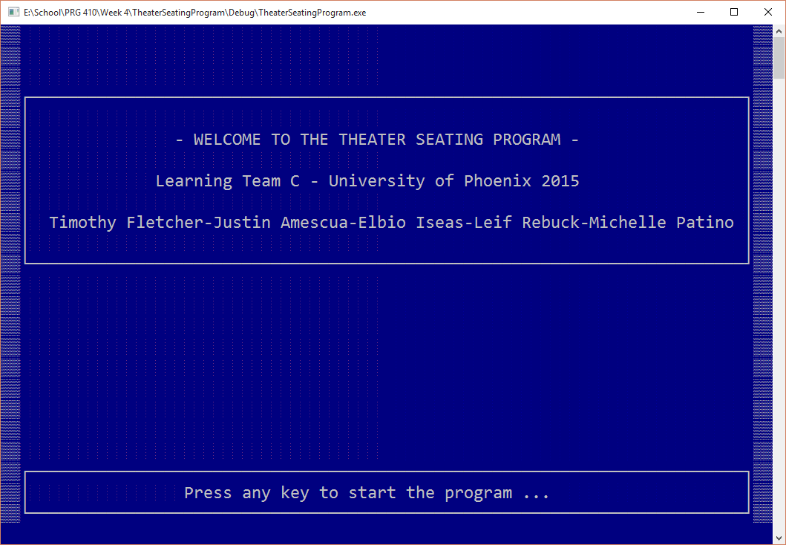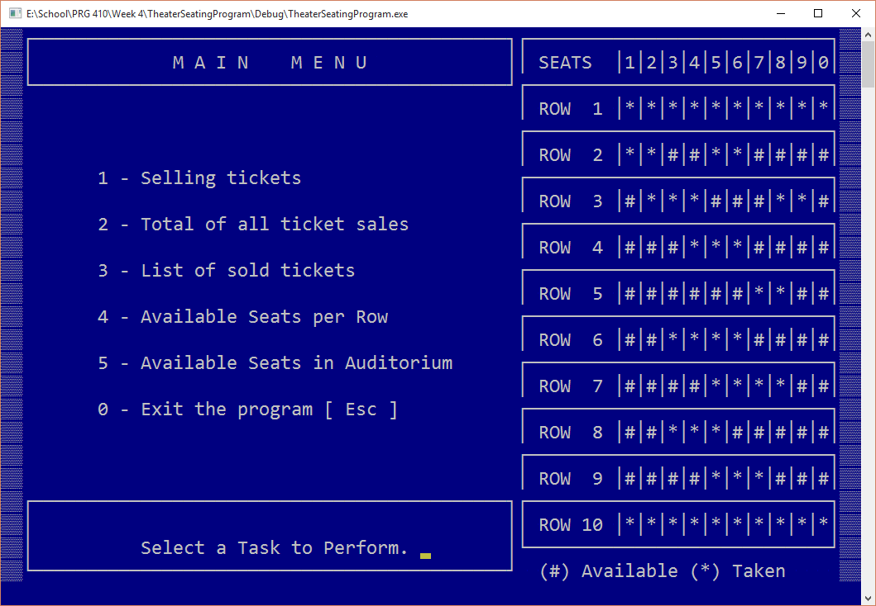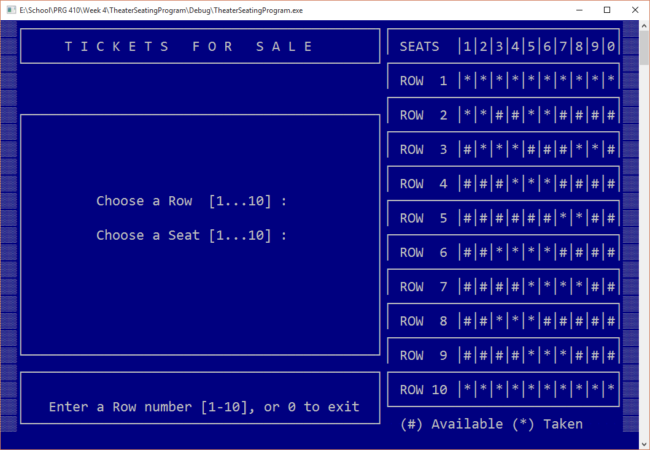
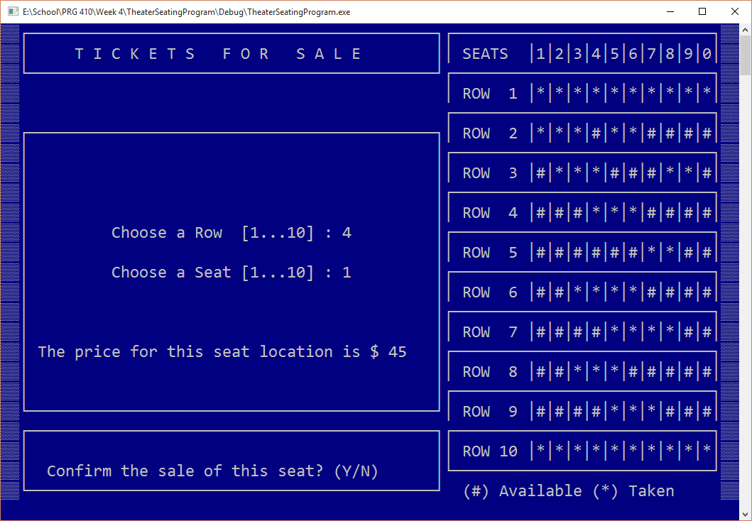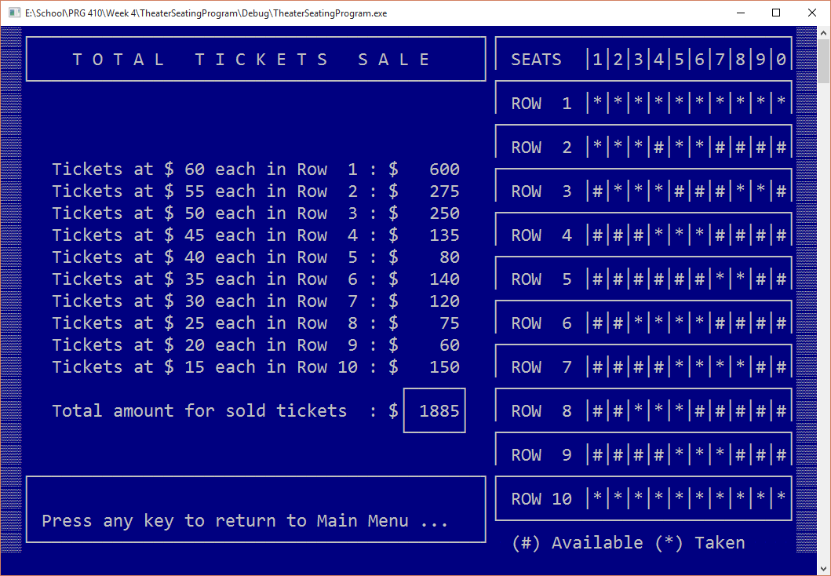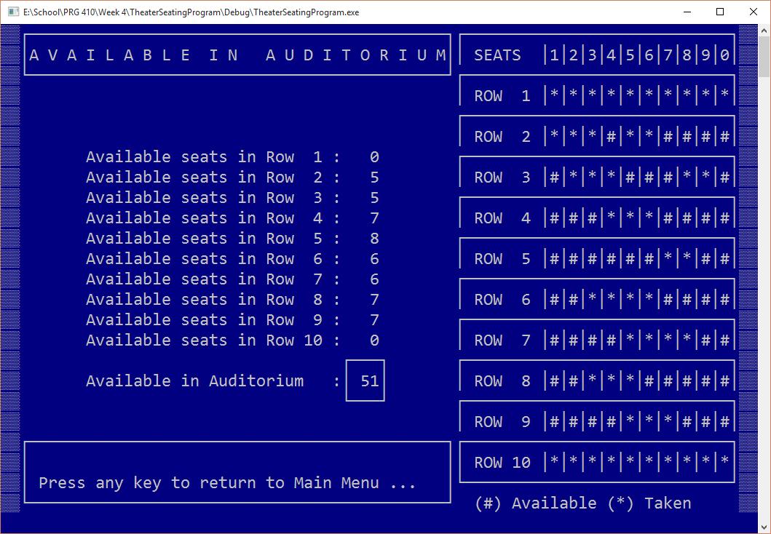
Testing:

Test 1: Does the program display the man menu? PASS.
Test 2: Does the all options of the main menu transition to the proper screen? PASS.
Test 3: Does the program properly terminate upon selection from the main menu? PASS.
Test 4: Does the program properly display the seating chart? PASS.
Test 5: Does the seating chart properly update when a seat is sold? PASS.
Test 6: Does the program properly display the cost of each row and seat? PASS.
Test 7: Does the program properly display and update the total ticket sales? PASS.
Test 8: Does the program properly display the available seats in the auditorium? PASS.

